Assignment 12

NAME: J.Sai Prakash
ROLLNO:2503a52380

Task Description #1 (Refactoring – Removing Code
Duplication)

• Task: Use AI to refactor a given Python script that contains
multiple repeated code blocks.
• Instructions:
o Prompt AI to identify duplicate logic and replace it
with functions or classes.
o Ensure the refactored code maintains the same output.
o Add docstrings to all functions.
• Sample Legacy Code:
# Legacy script with repeated logic
print(&quot;Area of Rectangle:&quot;, 5 * 10)
print(&quot;Perimeter of Rectangle:&quot;, 2 * (5 + 10))
print(&quot;Area of Rectangle:&quot;, 7 * 12)
print(&quot;Perimeter of Rectangle:&quot;, 2 * (7 + 12))
print(&quot;Area of Rectangle:&quot;, 10 * 15)
print(&quot;Perimeter of Rectangle:&quot;, 2 * (10 + 15))

Prompt :
Refactor the Python script below to remove repeated logic by placing the rectangle calculations and printing in a reusable function. Preserve the exact output text, order, and values. Add a docstring to every function you create, and return the complete refactored code.

Code :
def print_rectangle_dimensions(length, width):
"""Print the area and perimeter for a rectangle."""
print("Area of Rectangle:", length * width)
print("Perimeter of Rectangle:", 2 * (length + width))

print_rectangle_dimensions(5, 10)
print_rectangle_dimensions(7, 12)
print_rectangle_dimensions(10, 15)

output :
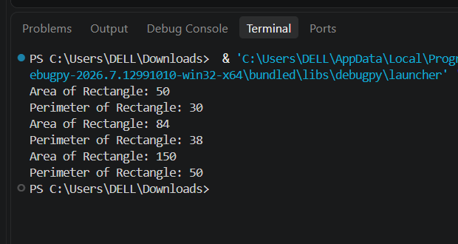
Prompt :
Refactor the Python script below to replace its nested search loop with set lookups while preserving the same membership logic and output text. Add a docstring to every function you introduce. Include a benchmark that compares the nested-loop and set-lookup approaches, and print a performance comparison table using measured timings. Make clear whether set creation is included in the benchmark.
Code:
from statistics import median
from timeit import repeat

names = ["Alice", "Bob", "Charlie", "David"]
search_names = ["Charlie", "Eve", "Bob"]
names_set = set(names)

def search_legacy(names, search_names):
"""Return membership messages using the original nested-loop approach."""
messages = []
for search_name in search_names:
found = False
for name in names:
if search_name == name:
found = True
if found:
messages.append(f"{search_name} is in the list")
else:
messages.append(f"{search_name} is not in the list")
return messages

def search_optimized(search_names, names_set):
"""Return equivalent membership messages using set lookups."""
return [
f"{search_name} is {'in' if search_name in names_set else 'not in'} the list"
for search_name in search_names
]

def benchmark(function, repeat_count=5, number=100_000):
"""Return the median elapsed time per function call in seconds."""
samples = repeat(function, repeat=repeat_count, number=number)
return median(samples) / number

legacy_messages = search_legacy(names, search_names)
optimized_messages = search_optimized(search_names, names_set)
assert legacy_messages == optimized_messages

for message in optimized_messages:
print(message)

number = 100_000
legacy_seconds = benchmark(
lambda: search_legacy(names, search_names),
number=number,
)
optimized_seconds = benchmark(
lambda: search_optimized(search_names, names_set),
number=number,
)
speedup = legacy_seconds / optimized_seconds if optimized_seconds else float("inf")

print("\nPerformance comparison (median of 5 runs; set creation excluded)")
print(f"{'Approach':<20} {'Time per call':>16}")
print(f"{'Nested loops':<20} {legacy_seconds * 1_000_000:>13.3f} us")
print(f"{'Set lookups':<20} {optimized_seconds * 1_000_000:>13.3f} us")
print(f"Speedup: {speedup:.2f}x")
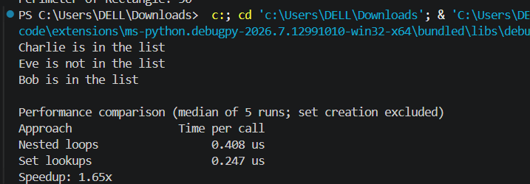
Task Description #3 (Refactoring – Extracting Reusable
Functions)
• Task: Use AI to refactor a legacy script where multiple
calculations are embedded directly inside the main code
block.
• Instructions:
o Identify repeated or related logic and extract it into
reusable functions.
o Ensure the refactored code is modular, easy to read,
and documented with docstrings.

• Sample Legacy Code:
# Legacy script with inline repeated logic
price = 250
tax = price * 0.18
total = price + tax
print(&quot;Total Price:&quot;, total)
price = 500
tax = price * 0.18
total = price + tax
print(&quot;Total Price:&quot;, total)
prompt :
Refactor the Python script below by extracting the repeated price, tax, and total calculation into a reusable function named calculate_total(price). Keep the 18% tax rate and preserve the original output text and values. Add a docstring to every function you create, then show the complete refactored code.
price = 250
tax = price * 0.18
total = price + tax
print("Total Price:", total)

price = 500
tax = price * 0.18
total = price + tax
print("Total Price:", total)

code:
def calculate_total(price):
"""Return the price with 18% tax added."""
tax = price * 0.18
return price + tax

for price in (250, 500):
total = calculate_total(price)
print("Total Price:", total)

output :
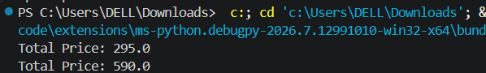

Task Description #4 (Refactoring – Replacing Hardcoded
Values with Constants)
• Task: Use AI to identify and replace all hardcoded “magic
numbers” in the code with named constants.
• Instructions:
o Create constants at the top of the file.
o Replace all hardcoded occurrences in calculations
with these constants.
o Ensure the code remains functional and is easier to
maintain.
• Sample Legacy Code:
# Legacy script with hardcoded values
print(&quot;Area of Circle:&quot;, 3.14159 * (7 ** 2))
print(&quot;Circumference of Circle:&quot;, 2 * 3.14159 * 7)

Prompt :
Refactor the Python code below by replacing hardcoded numeric values with named constants defined at the top of the file. Use PI = 3.14159 and RADIUS = 7 in both calculations. Preserve the output labels and values, and provide the complete refactored code.
print("Area of Circle:", 3.14159 * (7 ** 2))
print("Circumference of Circle:", 2 * 3.14159 * 7)

code :
PI = 3.14159
RADIUS = 7

print("Area of Circle:", PI * (RADIUS ** 2))
print("Circumference of Circle:", 2 * PI * RADIUS)

output :
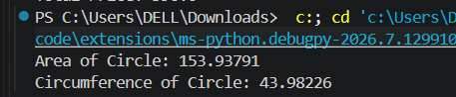

Task Description #5 (Refactoring – Improving Variable
Naming and Readability)
• Task: Use AI to improve readability by renaming unclear
variables and adding inline comments.
• Instructions:
o Replace vague names with meaningful ones.
o Add comments where logic is not obvious.

o Keep functionality exactly the same.
• Sample Legacy Code:
# Legacy script with poor variable names
a = 10
b = 20
c = a * b / 2
print(c)

code:
base = 10
height = 20

# A triangle's area is half the area of a rectangle with the same base and height.
triangle_area = base * height / 2
print(triangle_area)

output:
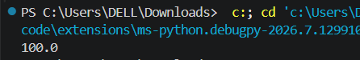

Task Description #6 (Refactoring – Removing Redundant Conditional
Logic)
• Task: Use AI to refactor a Python script that contains repeated if–else
logic for grading students.
• Instructions:
o Ask AI to identify redundant conditional checks.
o Replace them with a reusable function.
o Ensure grading logic remains unchanged.
Prompt :
Refactor the Python code below to remove the duplicated grading conditionals. Create a reusable function named calculate_grade(marks) with a docstring that returns the appropriate grade. Preserve the existing thresholds (90 for A, 75 for B; otherwise C) and output labels. Show the complete refactored code.
marks = 85
if marks >= 90:
print("Grade A")
elif marks >= 75:
print("Grade B")
else:
print("Grade C")

marks = 72
if marks >= 90:
print("Grade A")
elif marks >= 75:
print("Grade B")
else:
print("Grade C")

code:
def calculate_grade(marks):
"""Return the letter grade for marks using the original thresholds."""
if marks >= 90:
return "Grade A"
elif marks >= 75:
return "Grade B"
else:
return "Grade C"

for marks in (85, 72):
print(calculate_grade(marks))
Output:
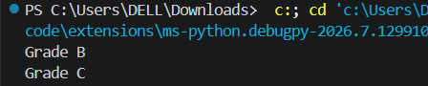-

Task Description #7 (Refactoring – Converting Procedural Code to
Functions)
• Task: Use AI to refactor procedural input–processing logic into
functions.
• Instructions:
o Identify input, processing, and output sections.
o Convert each into a separate function.
o Improve code readability without changing behavior.
• Sample Legacy Code:
num = int(input(&quot;Enter number: &quot;))
square = num * num
print(&quot;Square:&quot;, square)

prompt :
Refactor the Python script below into separate functions for input, processing, and output. Use clear, reusable function names and add a docstring to each function. Preserve the input prompt, calculation, and printed output. Include a main() function to coordinate the steps, and show the complete code.
num = int(input("Enter number: "))
square = num * num
print("Square:", square)
code:
def get_number():
"""Prompt for and return an integer from the user."""
return int(input("Enter number: "))

def calculate_square(number):
"""Return the square of a number."""
return number * number

def display_square(square):
"""Print the square using the original output label."""
print("Square:", square)

def main():
"""Run the input, calculation, and output steps."""
number = get_number()
square = calculate_square(number)
display_square(square)

if __name__ == "__main__":
main()

output :
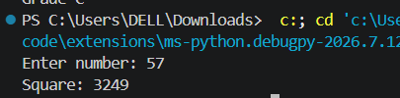

Task Description #8 (Refactoring – Optimizing List Processing)
• Task: Use AI to refactor inefficient list processing logic.
• Instructions:
o Ask AI to replace manual loops with list comprehensions or built-in
functions.
o Ensure output remains identical.
• Sample Legacy Code:
nums = [1, 2, 3, 4, 5]
squares = []
for n in nums:
squares.append(n * n)
print(squares)
prompt :
Refactor the Python code below to replace the manual loop and append() calls with a list comprehension or suitable built-in. Keep the output exactly the same and show the complete refactored code.
nums = [1, 2, 3, 4, 5]
squares = []
for n in nums:
squares.append(n * n)
print(squares)
code:
nums = [1, 2, 3, 4, 5]
squares = [number * number for number in nums]
print(squares)
output:
